Issue : Severals dumps on P11 with the following errors : CX_SADL_DUMP_DATABASE_FAILURE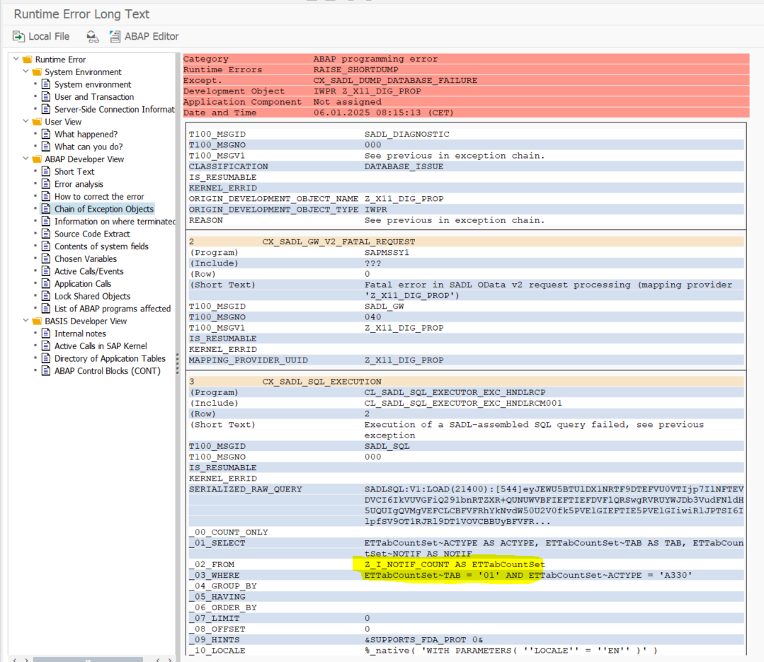

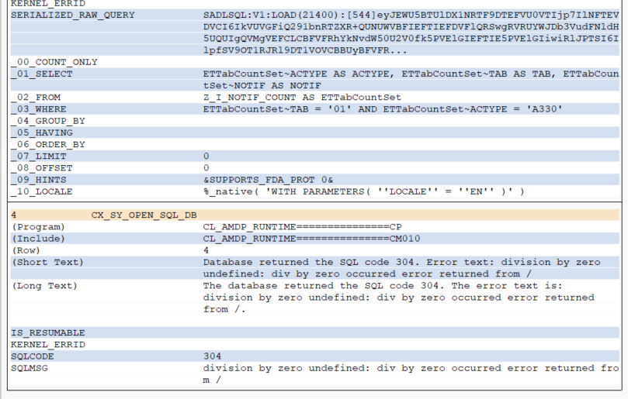
Technical details
Dump / Error is occurring in Entity set ETTabCountSet

CDS view : Z_I_NOTIF_COUNT
Reason: Error division by ZERO occurred in one of the internal CDS views of Z_I_NOTIF_COUNT

Explanation: For 2 PO’s 6500194545 ,6500194546 in P11 system , we have Quantity as Zero
So there is a logic in CDS Z_I_POP_FINAL , Z_I_OV_PO_DETAILS_ALL view which is dividing price by quantity
As the quantity is Zero , anything divided by zero will give an error.

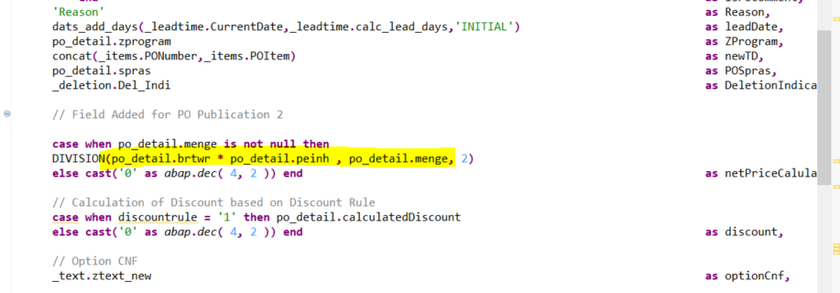

Impact in back end : ( P11 ):

A series of dumps/ Run time errors are occurred in backend system where CDS views are executed
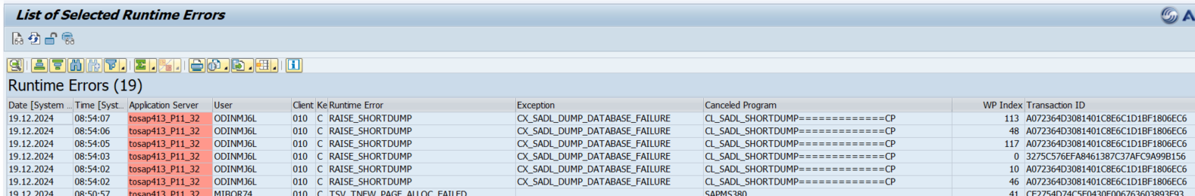

Impact in Front end ( DPD applications hosted in PFU system)

There are no errors in applications as reading only counters are failing . We could not check what's happening in applications in Production as we don't have access.

As confirmed by PPMS team there are no errors in DPD apps in production and no complaints from business team

Temporary solution implemented:

As issue is reported in P11 production system , we have identified 2 PO's 6500194545 ,6500194546 which have quantity ZERO and are not processed ( nast status ) are being considered by DPD applications and are causing the dump

We had a call with Alberto rossi the person who created the PO’s and based on his approvals we have deleted the not processed output type records in PO’s and hence those entries are removed from the NAST table.

From then on, Dumps/ Run time errors in P11 are stopped.

Permanent solution : As the CDS views are considering Po’s which have ZERO quantity for division which causes division by zero error

We need to check all the CDS views which have this logic and alter it such that PO’s which have zero quantity should be ignored

A check should be added as highlighted below 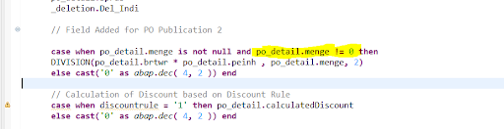

Replicating the same issue in the K11 system.

Example PO:6500004838

DPD apps before changes
Counter is displayed in red colour for each operation
A320
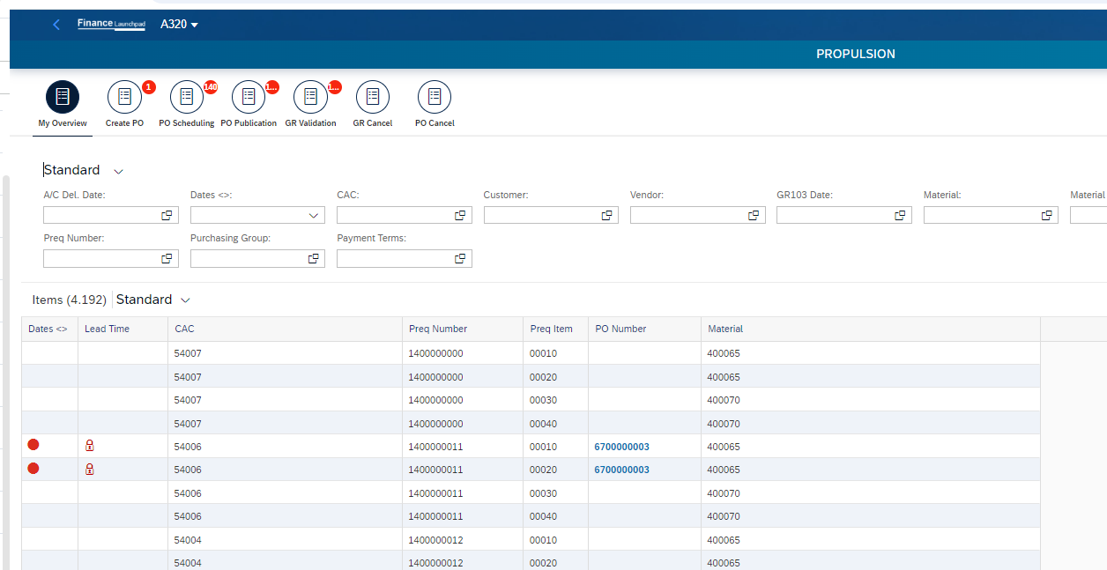

A330
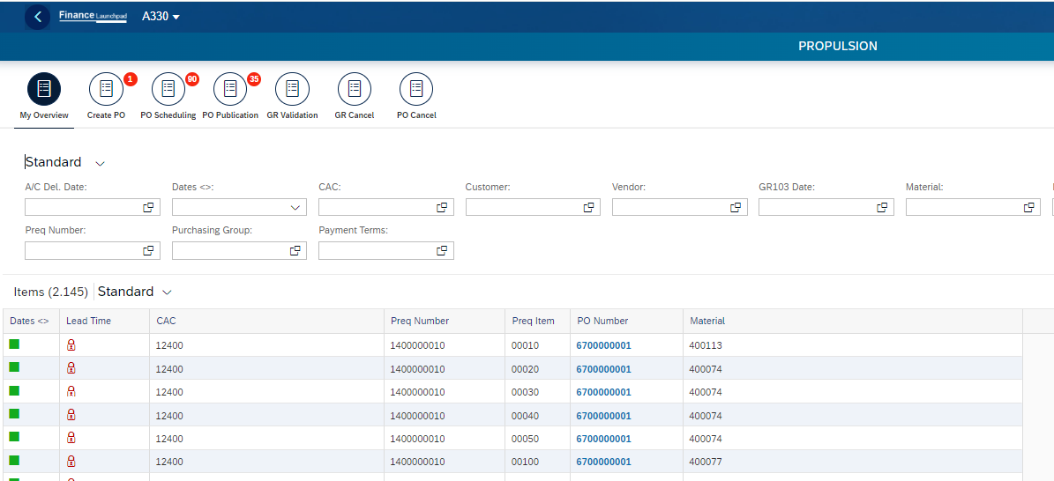

Changed quantity of PO to ZERO
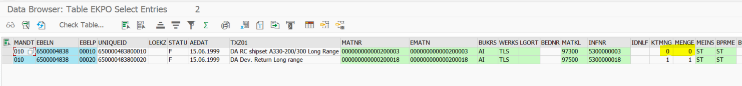

After replication
A320 - No counters are displayed on the icons
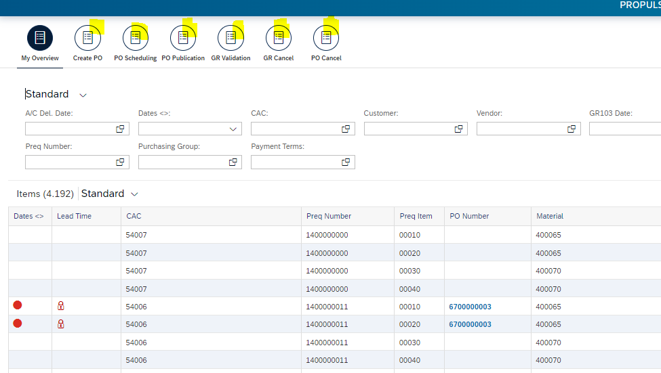

A330 - No counters are displayed on the icons
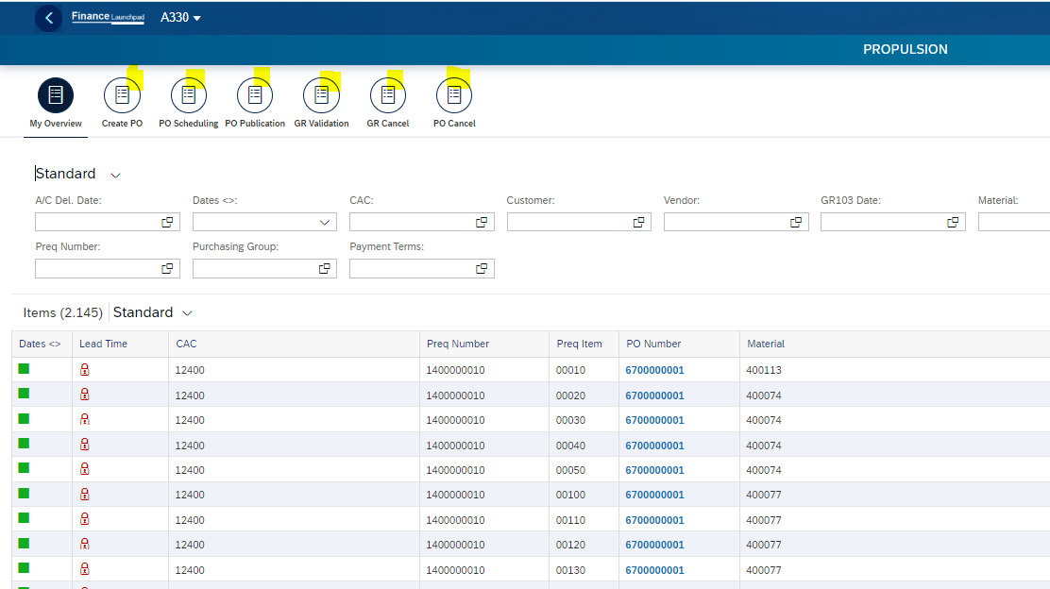

Reason for occurrence of dumps/ run time errors in K11 system is because this PO has zero quantity and used in division

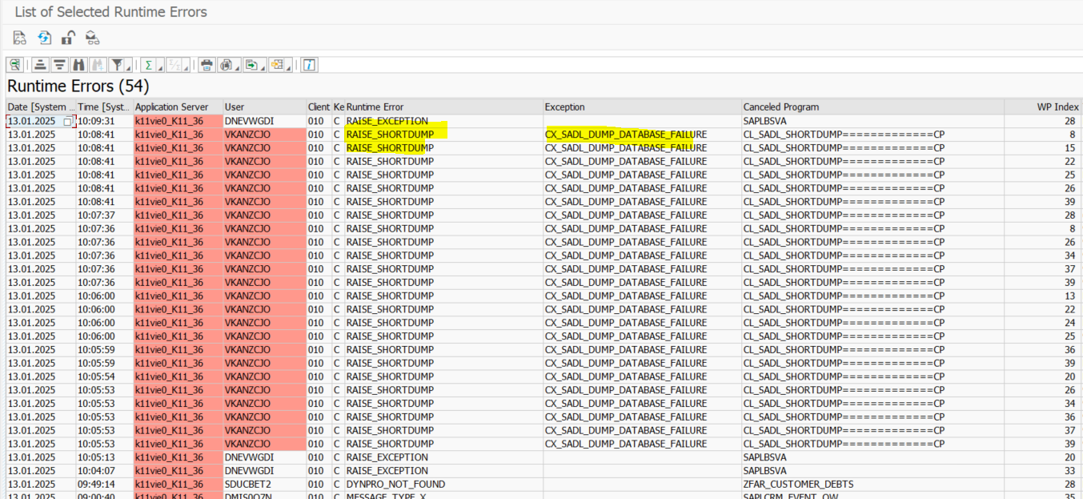

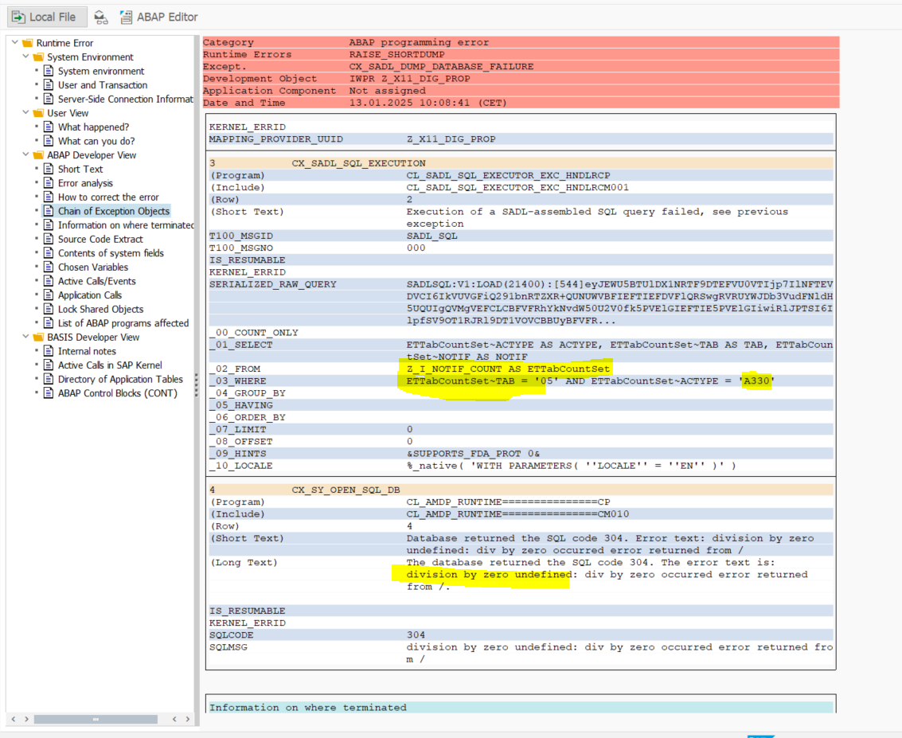

We couldn't identify the missing counter values in DPD applications in production because we lacked the necessary authorization to access the production environment. Our only visibility was through backend system P11 dumps.

Conclusion :
We should inform the PPMS team that this scenario will recur if a PO is created with zero quantity, causing the missing counters in DPD applications.
An incident or change request is necessary to implement a check in all CDS views, ensuring they exclude quantities with zero values."

